**C to C# 0 7 (FULL DIM 7)**

1. 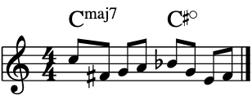
2. 